**What is HTML?**

HTML stands for Hyper Text Markup Language

HTML is the standard markup language for creating Web pages

HTML describes the structure of a Web page

HTML consists of a series of elements

HTML elements tell the browser how to display the content

HTML elements label pieces of content such as "this is a heading", "this is a paragraph", "this is a link", etc.

**A Simple HTML Document**

<!DOCTYPE html>  
<html>  
<head>  
<title>Page Title</title>  
</head>  
<body>  
  
<h1>My First Website</h1>  
<p>My first paragraph.</p>  
  
</body>  
</html>

**Example Explained**

The <!DOCTYPE html> declaration defines that this document is an HTML5 document

The <html> element is the root element of an HTML page

The <head> element contains meta information about the HTML page

The <title> element specifies a title for the HTML page (which is shown in the browser's title bar or in the page's tab)

The <body> element defines the document's body, and is a container for all the visible contents, such as headings, paragraphs, images, hyperlinks, tables, lists, etc.

The <h1> element defines a large heading

The <p> element defines a paragraph

**What is an HTML Element?**

An HTML element is defined by a start tag, some content, and an end tag:

<tagname> Content goes here... </tagname>

The HTML **element** is everything from the start tag to the end tag:

<h1>My First Heading</h1>

<p>My first paragraph.</p>

|  |  |  |
| --- | --- | --- |
| **Start tag** | **Element content** | **End tag** |
| <h1> | My First Heading | </h1> |
| <p> | My first paragraph. | </p> |
| <br> | none | none |

**Note:** Some HTML elements have no content (like the <br> element). These elements are called empty elements. Empty elements do not have an end tag!

**Web Browsers**

The purpose of a web browser (Chrome, Edge, Firefox, Safari) is to read HTML documents and display them correctly.

A browser does not display the HTML tags, but uses them to determine how to display the document:

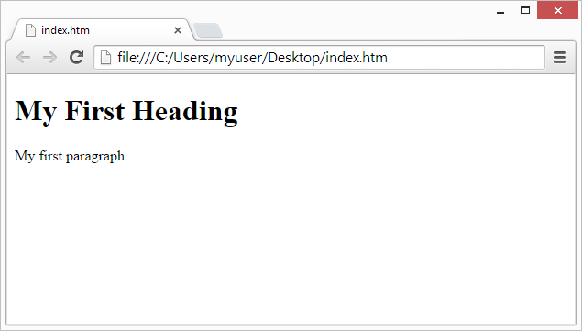

**HTML Page Structure**

Below is a visualization of an HTML page structure:

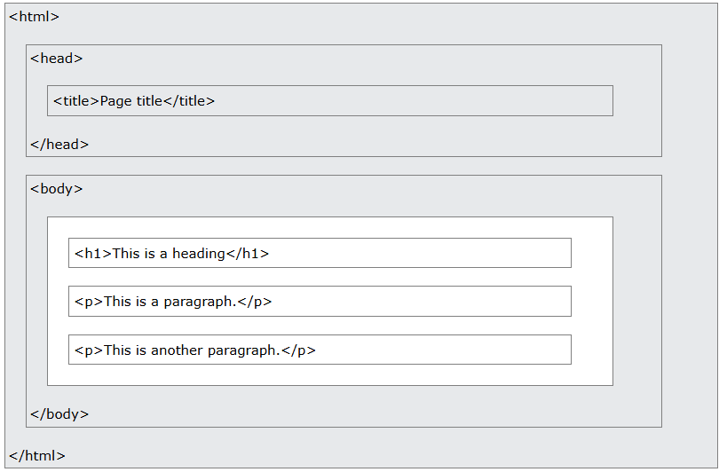

**Note:** The content inside the <body> section will be displayed in a browser. The content inside the <title> element will be shown in the browser's title bar or in the page's tab.

**HTML Editors**

Web pages can be created and modified by using professional HTML editors.

However, for learning HTML we recommend a simple text editor like Notepad (PC) or TextEdit (Mac), Vs Code, Sublime Text etc.

We believe that using a simple text editor is a good way to learn HTML.

Follow the steps below to create your first web page with Notepad or TextEdit.

Step 1: Open Notepad (PC)

Step 2: Write Some HTML

Save the file on your computer. Select **File > Save as** in the Notepad menu as filename.html

**Step 4: View the HTML Page in Your Browser**

Open the saved HTML file in your favorite browser (double click on the file, or right-click - and choose "Open with").